Prog # 2

Demetrius Johnson

**CIS 310 (Yoon)**

**June 26, 2021**

SCREENSHOT:

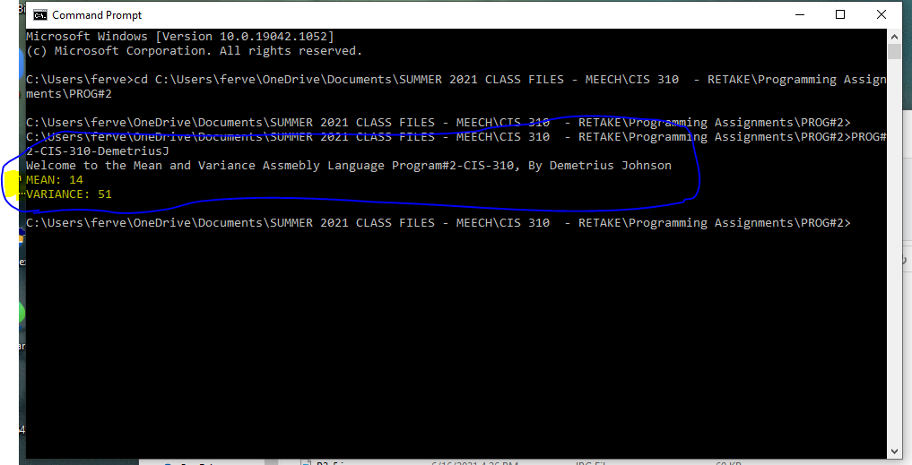

Note: for the .exe file I uploaded, I don’t have a system pause, so you will have to run it from your CMD prompt window by going to the proper directory where my program is downloaded on your system and then typing in my program name.